**Experiment 3: Thermodynamic functions from EMF measurements: Zinc-Copper system**

**Name:** Vidhi Shah

**Reg. No.:** 21BCE1297

**Slot:** L11-L12

**Date:** 5/10/21

**Part-A:**

**Determination of single electrode potentials of M/Mn+ system (EoM/Mn+) at two different concentrations.**

**Table 1: EMF measured for various concentrations of M/Mn+ system**

|  |  |  |  |  |
| --- | --- | --- | --- | --- |
| **Electrode/**  **Electrolyte** | **Concentration of**  **Electrolyte (N)** | **Ecell (V)**  **(EMF of the cell)** | **EM/M+ = Ecell + Ecalomel** | **EoM/M+** |
| **Zn/Zn2+** | 0.05 M | -1.047 | -0.803V | -0.757V |
| 0.1 M | -1.043 | -0.799V | -0.759V |
| **Cu/Cu2+** | 0.05 M | 0.037 | 0.281V | 0.327V |
| 0.1 M | 0.044 | 0.288V | 0.327V |

**Table 2: Individual activity coefficients of Cu2+ and Zn2+ in water at 25 °C**

|  |  |  |  |  |  |  |  |  |
| --- | --- | --- | --- | --- | --- | --- | --- | --- |
| **Metal ion system (Cu2+/Zn2+)** | 0.001 | 0.002 | 0.005 | 0.01 | 0.02 | 0.05 | 0.1 | 0.2 |
| **Activity coefficient (γc)** | 0.905 | 0.870 | 0.809 | 0.749 | 0.675 | 0.570 | 0.485 | 0.405 |

According to Nernst Equation:

EoM/M+ = EM/M+ - ln aMn+

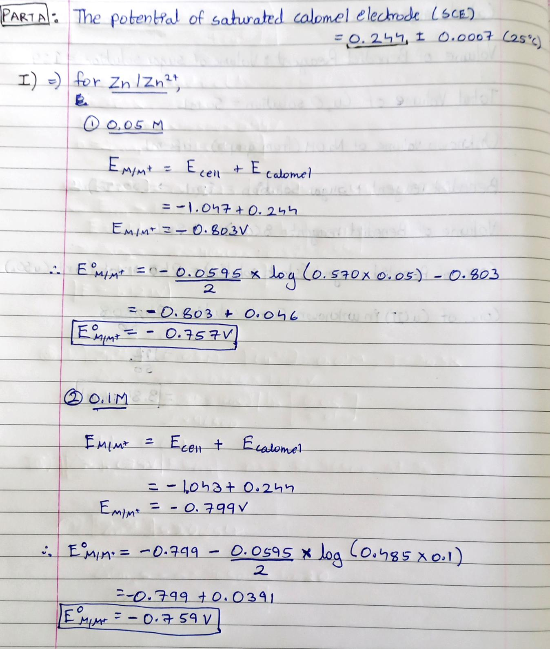**Calculation for Part A:**

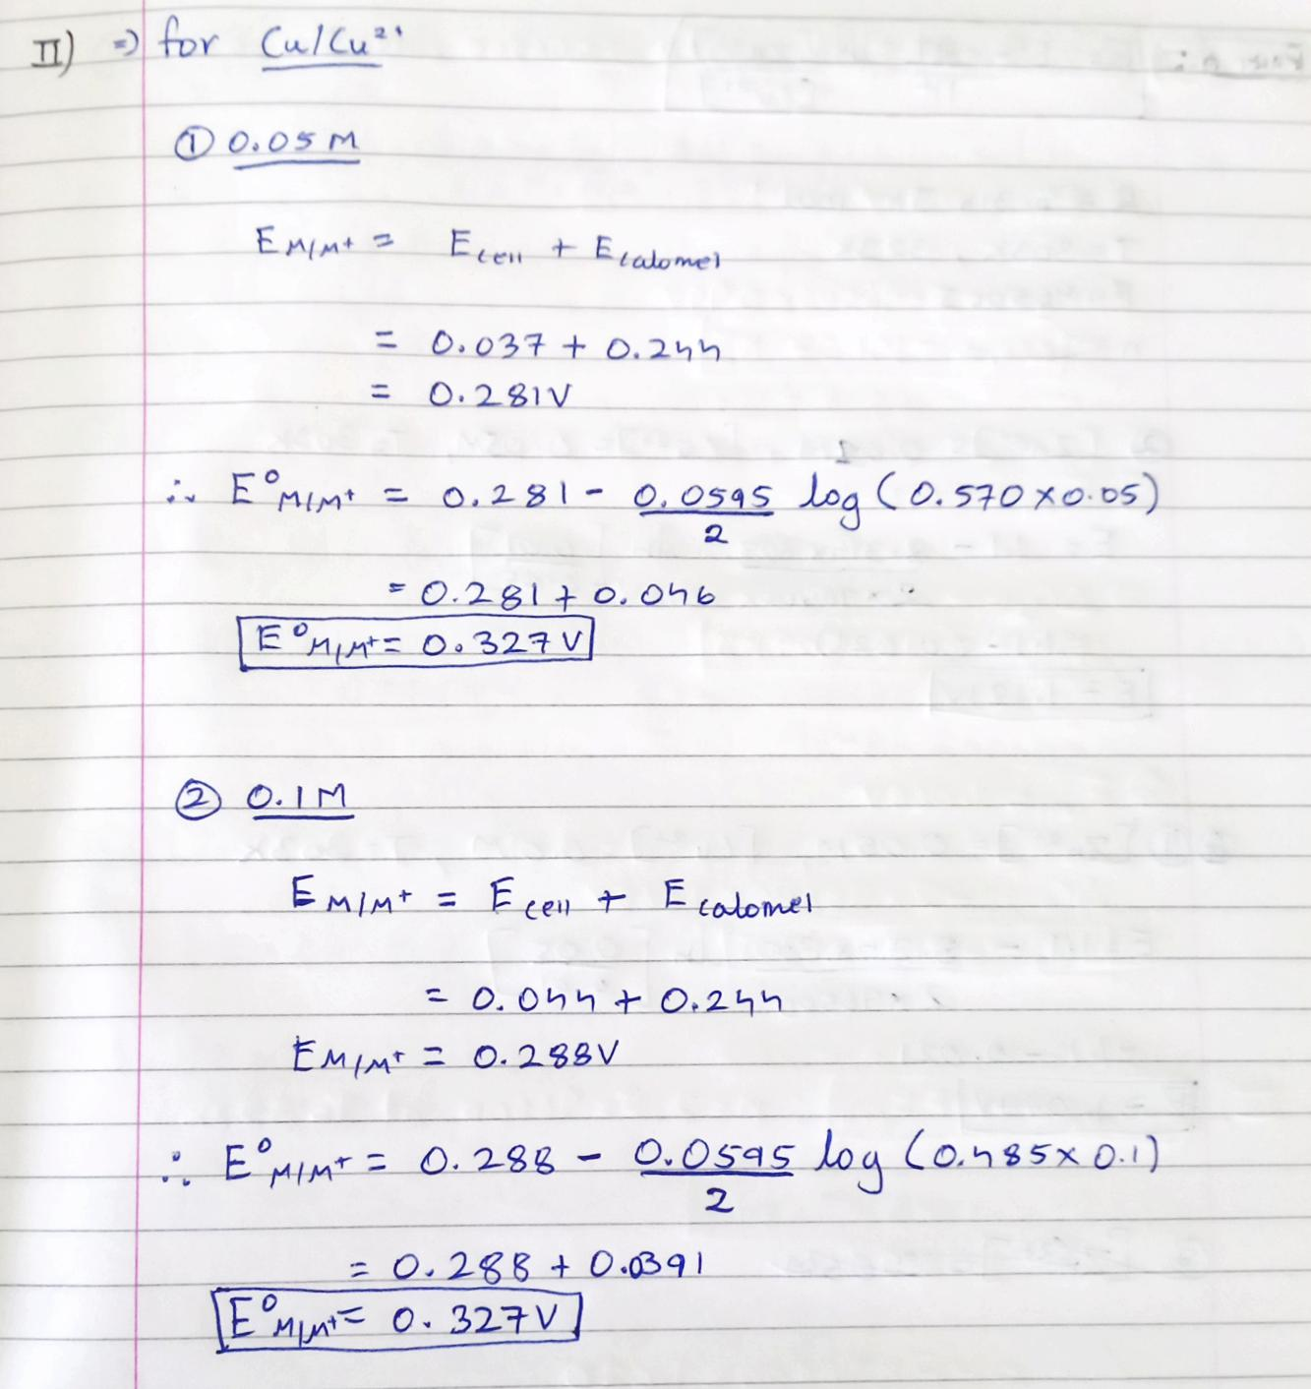

**Part-B:**

**Construction of Daniell cell and measurement of its voltage with three different concentrations of Copper and Zinc Salt Solutions.**

**Table 3**: **EMF of Daniell Cell observed (by calculation and experiment) from two different concentrations of zinc and copper solutions**

|  |  |  |  |  |  |
| --- | --- | --- | --- | --- | --- |
| **[Cu2+]** | **[Zn2+]** | **Ecell**  **(Calculated by Nernst Equation)** | **Ecell**  **(Experimental)** | **% Error** | **Free-energy change (∆G) or Wmax (KJ/mol)** |
| **At Room Temperature, T1 = 30 ºC / 303K** | | | | | |
| 0.01 M | 0.05 M | **1.079V** | **0.990V** | **8.2 %** | **-191** |
| 0.05 M | 0.01 M | **1.121V** | **1.013V** | **9.6 %** | **-196** |
| 0.1 M | 0.1 M | **1.100V** | **1.068V** | **2.9 %** | **-206** |
| **At T1a = 50ºC / 323 K** | | | | | |
| 0.01 M | 0.05 M | **1.078V** | **1.020V** | **6.4 %** | **-197** |
| 0.05 M | 0.01 M | **1.122V** | **1.036V** | **6.6 %** | **-200** |
| 0.1 M | 0.1 M | **1.100V** | **1.082V** | **1.6 %** | **-208** |

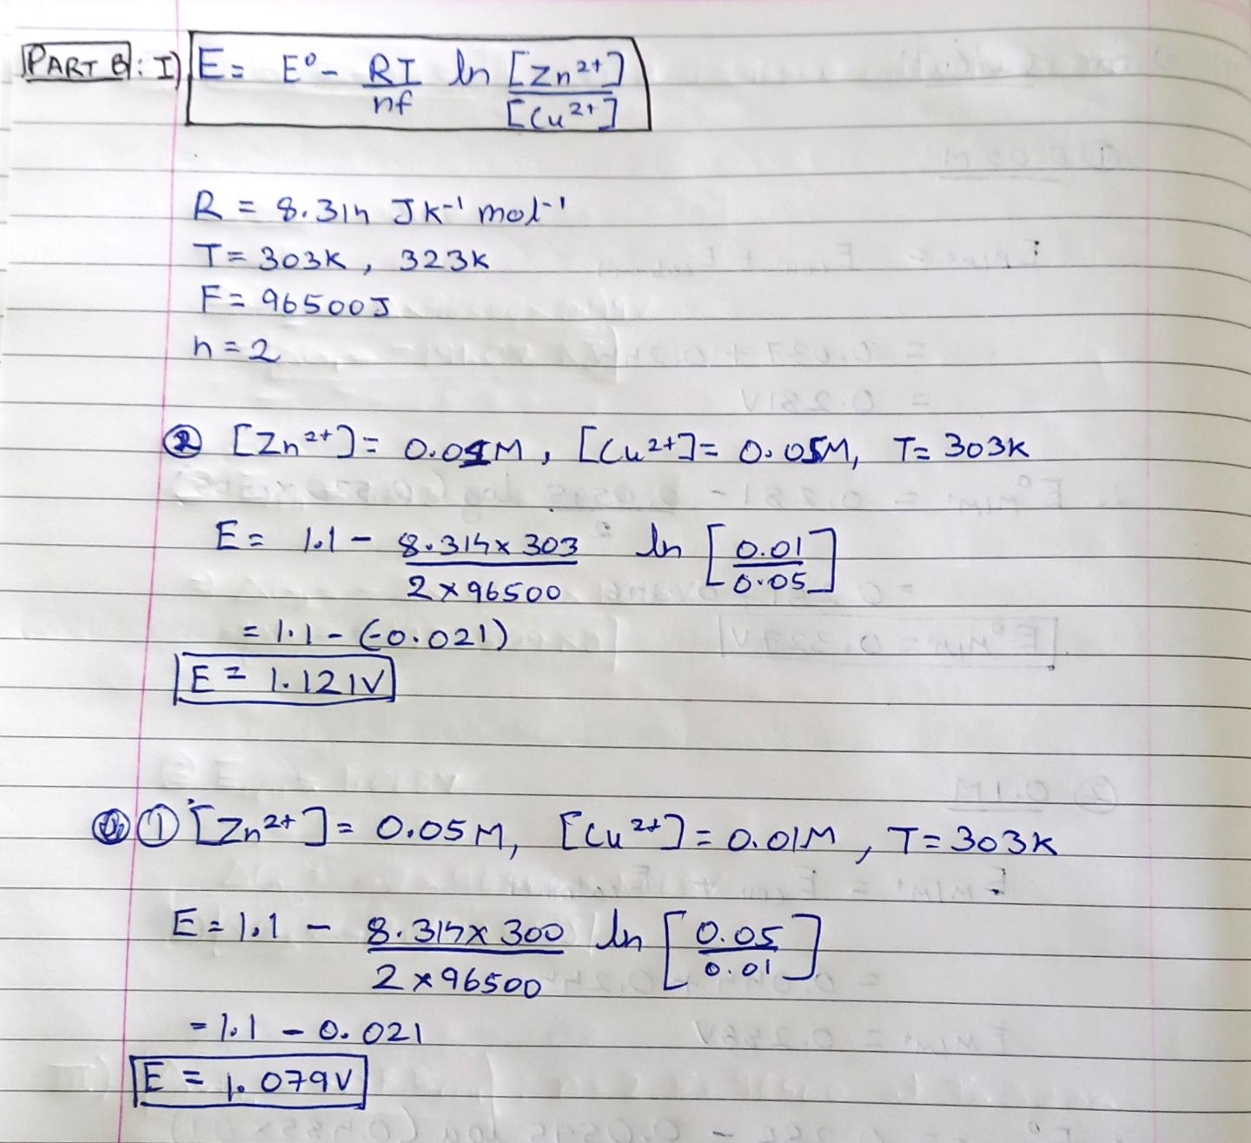**Calculation for Part B:**



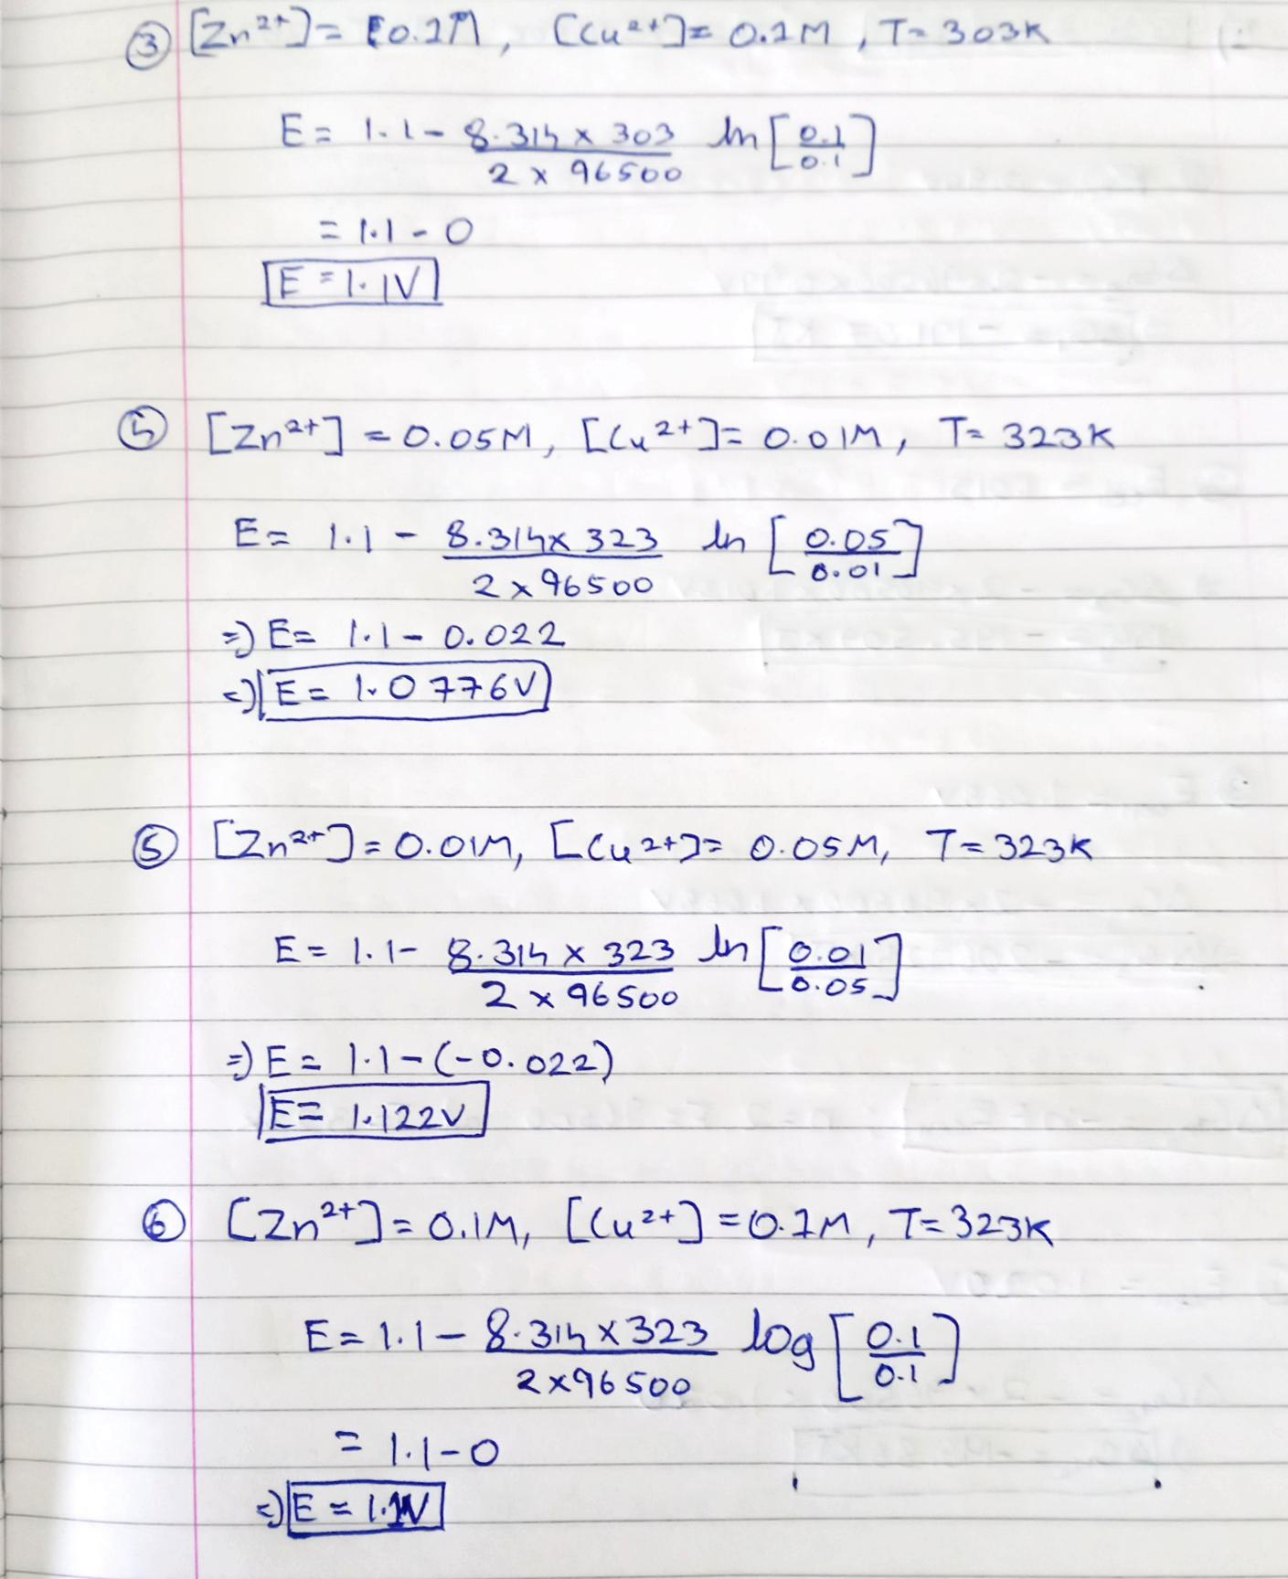



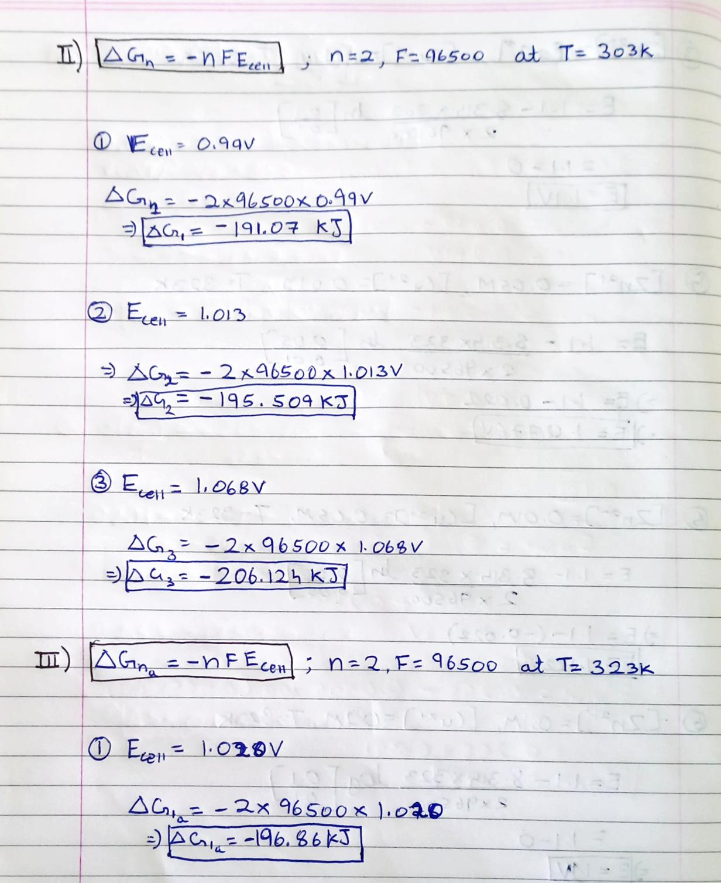



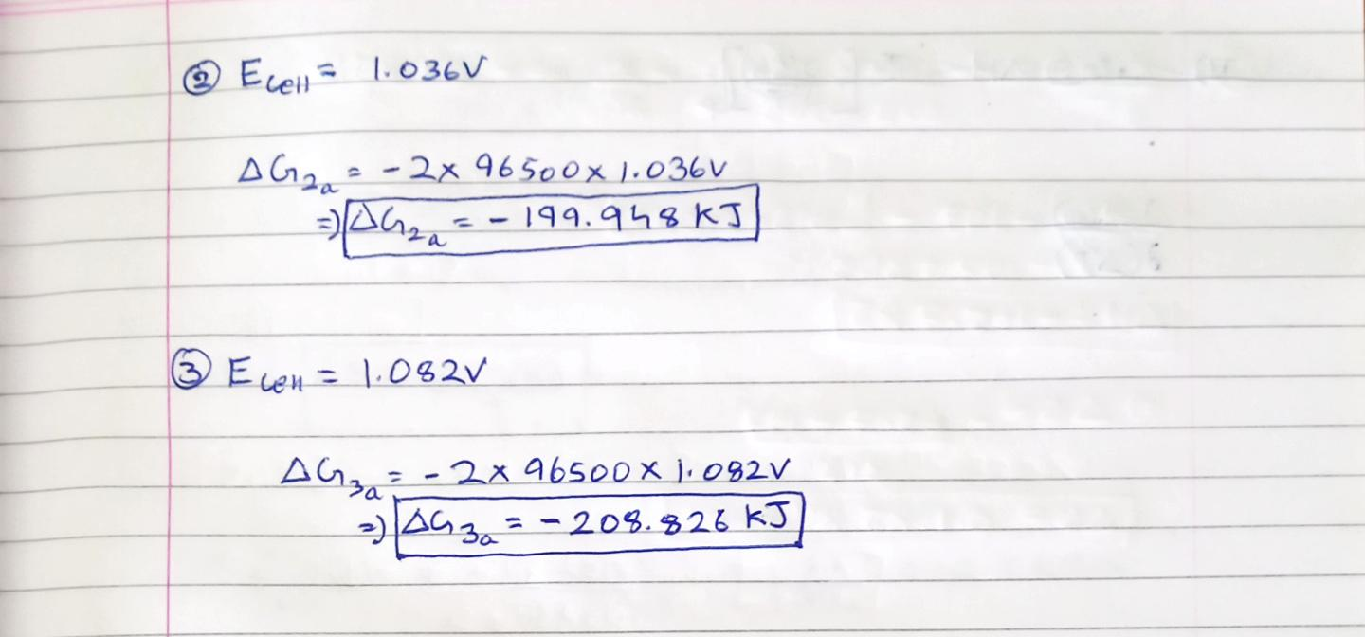

**Part-C:**

**Calculation of ∆H and ∆S at 40 ºC / 313 K based on the T1 and T1a parameters**

**Table-4: Final Results: At 313 K (40 ºC)**

|  |  |  |  |  |
| --- | --- | --- | --- | --- |
| **[Cu2+]** | **[Zn2+]** | **∆G**  **(KJ/mol)** | **∆H**  **(KJ/ mol)** | **∆S**  **(KJ⋅K−1⋅mol−1)** |
| 0.01 M | 0.05 M | -194 | -100.1 | 0.3 |
| 0.05 M | 0.01 M | -198 | -135.4 | 0.2 |
| 0.1 M | 0.1 M | -207 | -175.7 | 0.1 |

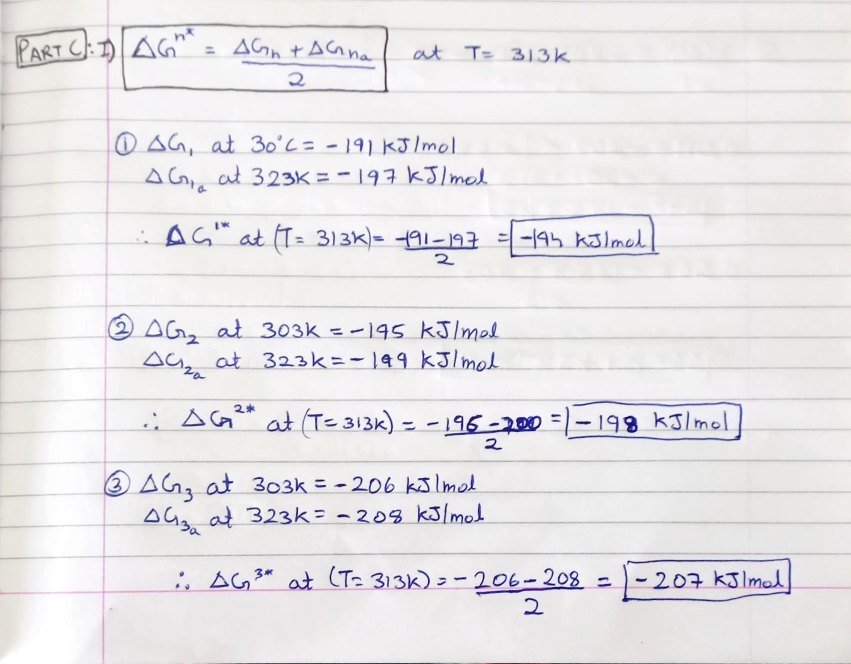**Calculation for Part C:**

